Fedorenkova Natalia

General information

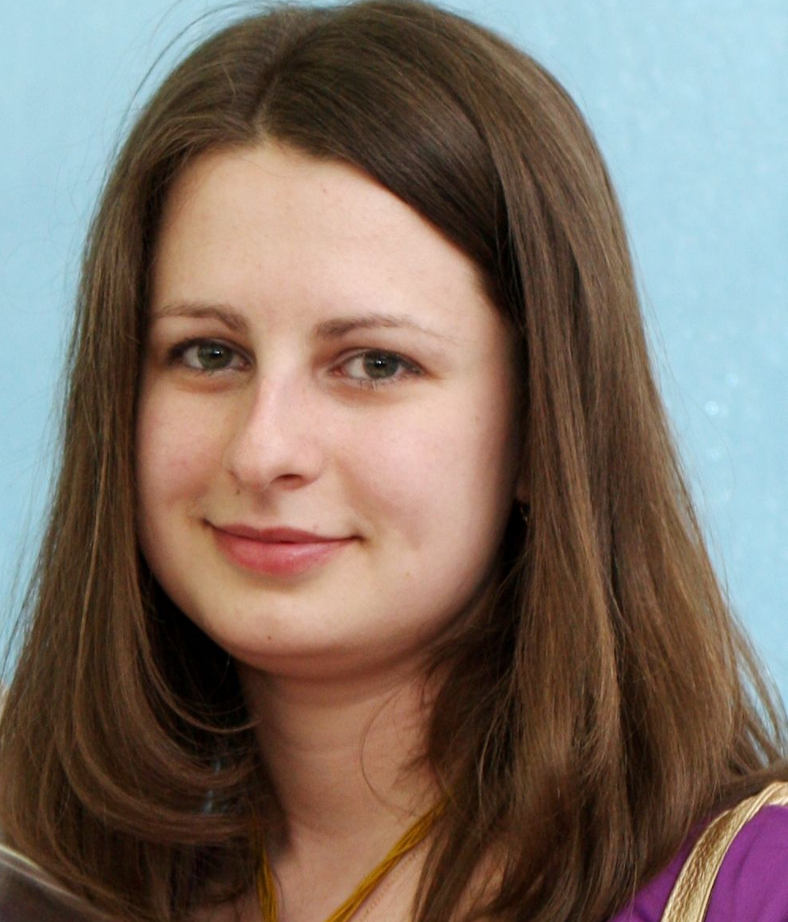 | Name: | Natalia Fedorenkova
 | Date of Birth: | 29 March 1985
 | Location: | Moscow, Russia
 | Citizenship: | Russia
 | Contacts: | Mobile tel.: +7 903 554 67 25  E-mail: nat.fedorenkova@gmail.com  Website: www.natfedorenkova.ru

Higher education

2002-2007 - Moscow State Lomonosov University (MSU), Faculty of Philology, Department of the Theory and Practice of Translation; qualification of a philologist, teacher, translator. Fluent English, second language - German, intermediate level, basic knowledge of Italian.
2010 - skill development program on consecutive translation in Moscow International School of Translation and Interpreting.
2012 - simultaneous interpreting program focused on oil and gas field.
2019 – skill development program Cultural and professional competences of an interpreter: the innovative model in the modern labour market conditions
2020 – English-Russian simultaneous interpreting course by Andrey Falaleyev, AIIC, 1st and 2nd modules
Participant, speaker and session moderator at Global Dialogue International Forum of Conference Interpreters (2017-2021), Ukrainian Translation Industry Conference UTIC 2020 and Contact conference for interpreters and translators (2021); organizer of RSI (remote simultaneous interpreting) webinars for conference interpreters and business; moderator of the RSI session at Translation Forum Russia 2020.

Services

Consecutive/conference (simultaneous) interpreting/whispering
Interpreting Languages: Russian (native) <> English

Particular experience in

Oil and gas, science, technologies, power industry
Aviation
Electricity
Banking, economics, accounting, consulting
IT
Advertising and marketing
Medical and pharma
Education, culture, travel, sport
Fashion and beauty

High-profile events:

2021 | Remote simultaneous interpreting at the UNECE event Launch of the national trade facilitation roadmap of the Kyrgyz Republic 2021-2025
 | Simultaneous interpreting at St. Petersburg International Economic Forum (SPIEF)
 | Remote simultaneous interpreting of the Standing Committee of the Executive Committee of the High Commissioner's Programme (80th meeting)
 | Remote simultaneous interpreting of the meeting on Faith and Science: towards COP 26 with participation of the Lord Archbishop of Canterbury and the Holy See
 | Remote simultaneous interpreting of UN FCCC webinars on Quality Assurance of the National Greenhouse Gas Inventory Management System and National Greenhouse Gas Inventories of Uzbekistan
2020 | Remote simultaneous interpreting of the meeting of UNHCR and the Regional Engagement Group for Asia and the Pacific on statelessness
2019 | Simultaneous interpreting at the Student Spring of the BRICS and SCO countries
 | Simultaneous interpreting at the 20th North Pacific Coast Guard Forum 2019
2018 | Consecutive interpreting for Information Technologies Department delegation from Pakistan at Public Health Department of Moscow
 | Consecutive interpreting at the meeting of the State Secretary – Deputy Minister of Transport of the RF Sergey Aristov with Extraordinary and Plenipotentiary Ambassador of India to the RF Pankaj Saran
 | Simultaneous and consecutive interpreting at X General Assembly of ICAPP (International Conference of Asian Political Parties). Consecutive interpreting of the welcoming address by the Chairman of the Supreme Council of United Russia Boris Gryzlov.
 | Consecutive interpreting of “Unknown Faberge” lecture by Sara Faberge at Junwex jewelry exhibition
2017 | Consecutive interpreter for the visit of the Nepal delegation to the Ministry of Finance of the Russian Federation
 | Consecutive interpreting at the meeting between Maxim Sokolov, the Minister of Transport of the RF, and Mr. Ki-tack Lim, IMO (International Maritime Organization) Secretary General
 | Simultaneous interpreting at a session of the Eurasian peoples' Assembly in the Civic Chamber of the Russian Federation
 | European Commission (EU Delegation to the Russian Federation). Simultaneous interpreting at the session on domestic violence legislation
2012 | Consecutive interpreter at World Gas Conference (WGC2012) in Kuala Lumpur, Malaysia

Work experience in specific areas

Oil and gas, science, technologies, power industry:

2021 | Simultaneous and consecutive interpreting at IAEA Regional Exercise on nuclear forensics of evidences and nuclear traces at a radiological crime scene
 | Remote simultaneous interpreting at the 25th Annual Meeting of Nuclear Forensics International Technical Working Group
 | Remote simultaneous interpreting of the International Workshop on efficient tools for reducing chemicals in urban ecosystems: NonHazCity project for St. Petersburg
2020 | Remote simultaneous interpreting of the VIII International Conference: Russian Offshore Oil & Gas Development: Arctic and Far East held by Gazprom VNIIGAZ LLC
 | Remote simultaneous interpreting of lectures by Politecnico di Torino professors at Gubkin Russian State University of Oil and Gas on energy efficiency, renewables and innovative technologies in the oil & gas industry
 | Remote simultaneous interpreting at SPE Virtual Annual Caspian Technical Conference
 | Remote simultaneous interpreting at Wilton Park’s webinar BRI (Belt and road initiative) investment in the energy sector: framing sustainable policy solutions for the post-COVID world
2019 | Simultaneous interpreting at VIII International Conference Gas Transportation Systems – Present and Future at Gazprom VNIIGAZ LLC
 | Consecutive interpreting at EOS 3D printing training organized by ABB Universal
 | Simultaneous interpreting of lectures by Politecnico di Torino professor at Gubkin Russian State University of Oil and Gas on innovative technologies in the oil & gas industry
 | Simultaneous interpreting at IX Annual Conference Neftegazstroy (Oil & Gas Industry Construction)
 | Simultaneous interpreting at IV International Conference Metalworking Fluids and Industrial Lubricants in Russia and CIS
 | Shushotage at the EHS Seminar at L’Oreal factory, the Kaluzhskaya region
 | Consecutive interpreting at the presentation of the 12th licensing round of Gabon Offshore
 | Consecutive interpreting of lectures by the Politecnico di Milano professor at Gubkin Russian State University of Oil and Gas on Advanced Project Management with special focus on EPC General Contracting in the oil&gas industry
 | Consecutive interpreting at Regional mining company
2018 | Consecutive interpreting at Cooperation Simulation Exercise on Nuclear Security COSINUS II in Dushanbe, Tajikistan
 | Simultaneous interpreting of lectures by Politecnico di Torino professor at Gubkin Russian State University of Oil and Gas for Rosneft employees on labour protection and functional safety
 | Simultaneous interpreting of lectures by Politecnico di Torino professor at Gubkin Russian State University of Oil and Gas for Rosneft employees on additive manufacturing, composite materials, non-destructive testing and new advanced technologies in the oil and gas industry
 | Consecutive interpreting at a number of meetings of a Dutch pump producer Pentair with potential Russian clients
 | Consecutive interpreting for Chiyoda Corporation at the technical audit at the Kolomensky plant (diesel engines and locomotives)
 | Consecutive interpreting for System Cleaners, Denmark (producer of industrial cleaning machines) at Agroprodmash exhibition
 | Consecutive interpreting for the Danish company «System Cleaners» (production of industrial cleaning equipment) at Agroprodmash exhibition
 | Participation in a joint project of Air Products and Kriogenmash on designing an industrial plant in Uzbekistan (consecutive interpreting)
 | Simultaneous interpreting at IX Industrial Conference “Gazprom’s welding production: current state and main development areas”
 | Simultaneous interpreting at VII International Conference “Russian Offshore Oil and Gas Development: Arctic and Far East” (ROOGD-2018) held in Gazprom VNIIGAZ
2012 – 2018 | CB&I Lummus, company engaged in process technologies and oil refining; interpreter/translator in the Business Development Department; responsibilities: translation of technical descriptions, specifications, contracts, business correspondence; interpreting at negotiations, accompanying company specialists in business trips.
2017 | Independent Petroleum Company (IPC). Consecutive interpreter at a meeting with investors
 | Simultaneous interpreting of EAGE (European Association of Geoscientists & Engineers) courses on seismic attributes, geostatistics and deepwater sedimentary systems
 | Simultaneous interpreting of lectures by Politecnico di Torino professors at Gubkin Russian State University of Oil and Gas for Rosneft employees on energy efficiency and renewables
 | Simultaneous interpreting at XI International Forum and Exhibition Professional Radio Connection, Satellite Communications and Navigation
2008 – 2012 | Gazprom VNIIGAZ (R&D branch of Gazprom), interpreter/translator in the international department; responsibilities: translation of technical reports, presentations, papers, business correspondence and legal contracts; interpreting at technical and business negotiations, working meetings, workshops, conferences; communication with freelance translators and translation agencies, editing received translations; accompanying company specialists in business trips to Russia and abroad

Aviation

2021 | Consecutive interpreting of Type Rating Ground Course: A109S Helicopters
2018-2020 | Simultaneous interpreting at V, VI and VII National Aviation Infrastructure Show
2019 | Consecutive interpreting of Type Rating Ground Course: AW139 Helicopters

Electricity
2019 | Simultaneous interpreting of Tavride Electric training course on switching devices
 | Simultaneous interpreting at the International Forum on Power Grids
2018 | Consecutive interpreting at the Feasibility Study presentation by Schneider Electric

Banking, economics, finance, accounting, consulting, management, insurance:

2021 | Remote consecutive interpreting at the audit of beer brewing plant, BSI
2020 | Remote simultaneous interpreting of the Introduction to Sustainable Public Procurement Webinar under the United Nations Project Enhancing sustainable public procurement for the regional transition to inclusive green economy in Eastern Europe, Caucasus and Central Asia
 | Remote simultaneous interpreting of Moscow Academic Economic Forum Technical and socio-economic transformations of the 21st century: the experience of conceptual understanding organized by S.Y. Witte Institute for New Industrial Development
2019 | Remote simultaneous interpreting at the Europe Cash Cycle Seminar (ICCOS), Tbilisi, Georgia
 | Remote simultaneous interpreting at the IAIABC Worker’s Compensation Conference, San Diego, the USA
2018 | Simultaneous interpreting of a conference call in an accounting department of Imperial Tobacco
 | Consecutive interpreting at a meeting between Boston Consulting Group and AO Waste Management
 | Simultaneous interpreting at a 66th FCEM World Congress (World Association of Women-Entrepreneurs)
2017 | Simultaneous and consecutive interpreting in Rosbank (weekly session of the Board, trainings and projects)
 | Unipro PJSC (E.ON Russia JSC). Consecutive interpreter at the meeting with the Head for Procurement, Germany
 | Consecutive interpreter at audit of Alcatel-Lucent Training Centre

IT:

2020 | Remote simultaneous interpreting of RNUG conference
2020 | Remote simultaneous interpreting of Hewlett Packard Enterprise Discover Virtual Experience
2019 | Simultaneous interpreting of the Course on data management, data modelling and data protection against cyber attacks for Lukoil top managers
 | Simultaneous interpreting at Conversations conference on artificial intelligence, voice assistants and chatbots
 | Simultaneous interpreting at an IT workshop for Sberbank Service LLC
2018 | Consecutive interpreting for Information Technologies Department delegation from Pakistan at Public Health Department of Moscow
 | Simultaneous interpreting at pump selection software workshop held by Russian Association of Pump Manufacturers at Bauman Moscow State Technical University
 | Simultaneous interpreting at Gartner’s briefing for CEO on digital business and transformations
 | Consecutive interpreting at meetings between Silicom and its partners (IT)
 | Simultaneous interpreting at Gartner’s briefing on optimization of customer experience with machine learning and artificial intelligence
 | Simultaneous interpreting at Gartner’s briefing on digital leadership and monetization for financial services
2017 | Simultaneous interpreting at XI International Forum and Exhibition Professional Radio Connection, Satellite Communications and Navigation

Medical and pharma:

2021 | Remote simultaneous interpreting at Eli Lilly webinar on prevention of cardiovascular events in Type2 diabetes
 | Remote simultaneous interpreting of the virtual investigator meeting on Impassion050 clinical study (Roche)
 | Remote simultaneous interpreting of the virtual meeting of the Italy Hub of Eli Lilly
 | Remote simultaneous interpreting of the virtual meeting of investigators of Roche and Genentech
 | Remote simultaneous interpreting of the Virtual Investigator Meeting on Studies in Retinal Vein Occlusion (RVO) and clinical trials
2020 | Remote simultaneous interpreting at the Webinar on MS (multiple sclerosis) digital management tools
 | Remote simultaneous interpreting at V Conference on Spinal Muscular Atrophy (SMA)
 | Remote simultaneous interpreting of Baxter virtual conference (pharma)
2019  2006-2019  2018-2019 | Consecutive interpreting at the Bobath therapy training course for physical therapists
 | Consecutive interpreting at the 1st training course for practitioners of the Feldenkrais method in Russia
 | Remote simultaneous interpreting of the webinar Metastatic Breast Cancer
 | Remote simultaneous interpreting of the webinar Epilepsy and Pregnancy
 | Remote simultaneous interpreting of the webinar on psoriasis: The Importance of Achieving Complete Skin Clearance and Improvement of Hard-to-Treat Areas for Patients with Psoriasis
 | Simultaneous interpreter at Bernafon International Distributer Forums 2006-2019 (once a year) in Switzerland
 | Consecutive interpreting at Bernafon workshops on hearing aids
 | Consecutive interpreting at III Conference on Spinal Muscular Atrophy (SMA)
2018 | Simultaneous interpreting at the presentation of a marketing campaign by Starlink media agency at Dr.Reddy’s office (pharmaceutical company)
 | Simultaneous interpreting at the Conference “Future depends on us: technologies and practices for employment of young people with disability”
2017 | First Eurasian Orthopedic Forum. Simultaneous interpreting at Children’s Traumatology and Orthopedics Section and consecutive interpreter
 | Consecutive interpreting at a meeting between a Russian advertising agent Densu Aegis and Polpharma, Polish pharmaceutical company
 | First Eurasian Orthopedic Forum. Simultaneous interpreting at Children’s Traumatology and Orthopedics Section and consecutive interpreter
 | Consecutive interpreting at a meeting between a Russian advertising agent Densu Aegis and Polpharma, Polish pharmaceutical company
2007 – 2008 | Aeron, the company with representative functions of Bernafon, the swiss hearing aid manufacturer, the position of an assistant of the general director. Responsibilities: administrative support of the general director, translation of technical information, brochures and website, consecutive and simultaneous interpreting

Advertising and marketing:

2020 | Remote simultaneous interpreting of Mondelez virtual town hall
2020 | Remote simultaneous interpreting of focus groups (Radar research company)
2018 | Simultaneous interpreting at the presentation of a marketing campaign by Starlink media agency at Dr.Reddy’s office (pharmaceutical company)
 | Simultaneous interpreting at the presentation of a marketing campaign by Starlink media agency at Red Bull’s office
2017 | Cosecutive interpreting at a meeting between a Russian advertising agent Densu Aegis and Polpharma, Polish pharmaceutical company

Education, culture, travel, sport:

2019 | Simultaneous interpreting at the III International Budo-Conference Education of personality and self-development: martial arts traditions and contemporary science
 | Remote simultaneous interpreting at the 3rd Meeting of the US-Russia Dialogue, Chicago, the USA
2018 | Simultaneous interpreting at the International Forum “Active Longevity”, Moscow 2018
 | Consecutive interpreting at the master-class of an American screenwriter Paul Brown at the 15th International exhibition of equipment, services and new technology for cinema production (CPS 2018)
 | Consecutive interpreting of the famous architect Jan Gehl during the press-conference on II Climatic Urban Forum in TASS
2017 | Consecutive interpreting at the meeting of the Leading Hotels of the World (LHW) Association
 | Simultaneous interpreting at the International Charity Festival Inclusive Dance
 | Simultaneous interpreting at VI International Conference Early Childhood Care and Education (ECCE)

Fashion and beauty:

2020 | Consecutive interpreting of the designer in Eden wedding saloon
2019 | Simultaneous interpreting at Lush showcase in Liverpool, the UK

Politics, social sciences, law enforcement:

2021 | Remote simultaneous interpreting of meetings with representatives of Central Asia countries 0n LEICA project (law enforcement in Central Asia) supported by the European Commission and Civipol

